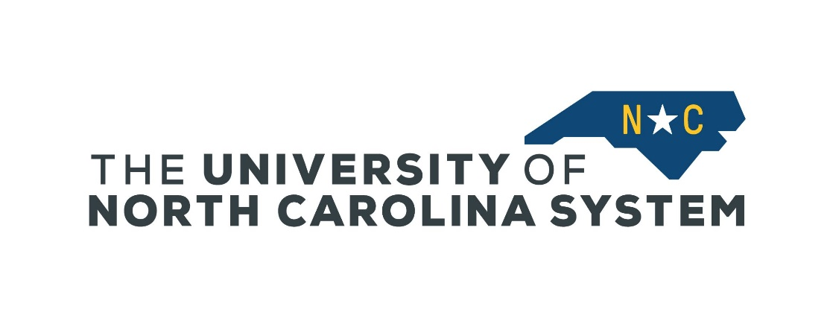
University of North Carolina System
Virtual Military Education Fair
April 26th and April 27th, 2021
12:00 pm – 2:00 pm

Day 1 (April 26th) RDS, Application & Resource Information, VA Benefits
Day 1 Zoom Link: https://northcarolina-edu.zoom.us/j/99468301814
Meeting ID: 994 6830 1814
Passcode: MilitaryEd
One tap mobile: +13126266799,,99468301814#,,,,*8719145861# US (Chicago)
+19294362866,,99468301814#,,,,*8719145861# US (New York)
Find your local number: https://northcarolina-edu.zoom.us/u/ackUN7zEtT

12:00 pm Welcome: Siobhan Norris, UNC System Office
12:05 pm Remarks: Peter Hans, President, UNC System
12:10 pm Keynote: Dr. James Winebrake, Provost, UNC Wilmington
12:20 pm Residency for military connected students: Gene Ritter, Residency Determination Service (RDS)
12:45 pm Understanding the application process, transferring credit, and requesting Joint Service Transcripts (JSTs): Veronica Alexander, Fayetteville State University
1:15 pm Utilizing VA education benefits: Daniel Hackley, NC State University
1:45 pm Q&A and Wrap Up

Day 2 (April 27th) Meet Your UNC Universities!
Day 2 Zoom Link: https://northcarolina-edu.zoom.us/j/91557045289
Meeting ID: 915 5704 5289
Passcode: MilitaryEd
One tap mobile: +19294362866,,91557045289#,,,,*0789591970# US (New York)
+13017158592,,91557045289#,,,,*0789591970# US (Washington DC)
Find your local number: https://northcarolina-edu.zoom.us/u/agrtnUlta

12:00 pm Welcome: Siobhan Norris, UNC System Office
12:05 pm Keynote: “Making an informed decision in choosing your university and degree program,” Tanya Ang, Vice President, Veterans Education Success (VES)
12:15 -2:00 pm Meet Your UNC Universities (panel discussions)
12:15–1:00 pm UNC Chapel Hill, UNC Pembroke, Fayetteville State University, UNC Wilmington, NC State University, East Carolina University, Elizabeth City State University, NC Central University
1:00 – 1:45 pm Appalachian State University, NC A&T, UNC Asheville, UNC Charlotte, UNC Greensboro, UNC School of the Arts, Western Carolina University, Winston Salem State University

