Amplify GenAI User Guide

Introduction
Amplify GenAI is Vanderbilt University’s open‑source enterprise generative AI platform designed for organizations. It supports multiple model providers (Anthropic Claude, OpenAI GPT‑4 Turbo and others) and gives users control over their data and integrations[1]. The platform lets you build custom assistants, upload files and share content within your organization while keeping costs manageable[2]. Unlike proprietary AI products that lock you into a single provider, Amplify GenAI’s architecture allows you to switch between providers or self‑host models to suit your needs[2]. Pricing is usage‑based – you deploy Amplify in your own AWS account and pay only for AWS hosting and the model tokens you consume[3], which can significantly reduce costs versus per‑seat licensing.

Getting Started

Navigation & Theme
When you first log in, Amplify displays a sidebar with three main sections:
- Conversations tab for chats with the models.
- Assistants tab for creating and managing assistants and prompt templates.
- Administration hammer tab for importing/exporting conversations and other administrative tasks.
Under Settings → Configurations you can choose between Dark and Light modes and select the model families available to users (e.g., Claude 3.5 Haiku, GPT‑4o‑mini)[2]. Features such as artifacts, focused messages and plugin selector can also be toggled on or off from this panel.

Starting a Conversation
To begin a chat, click New Chat in the sidebar. A configuration panel lets you pick the model, select optional custom instructions and adjust the temperature (randomness) and response length. Move the sliders toward Precise for focused answers or toward Creative for more varied responses. Once configured, type your prompt in the input field and hit Enter to chat. Each conversation is listed in the left pane by date so you can revisit it later.
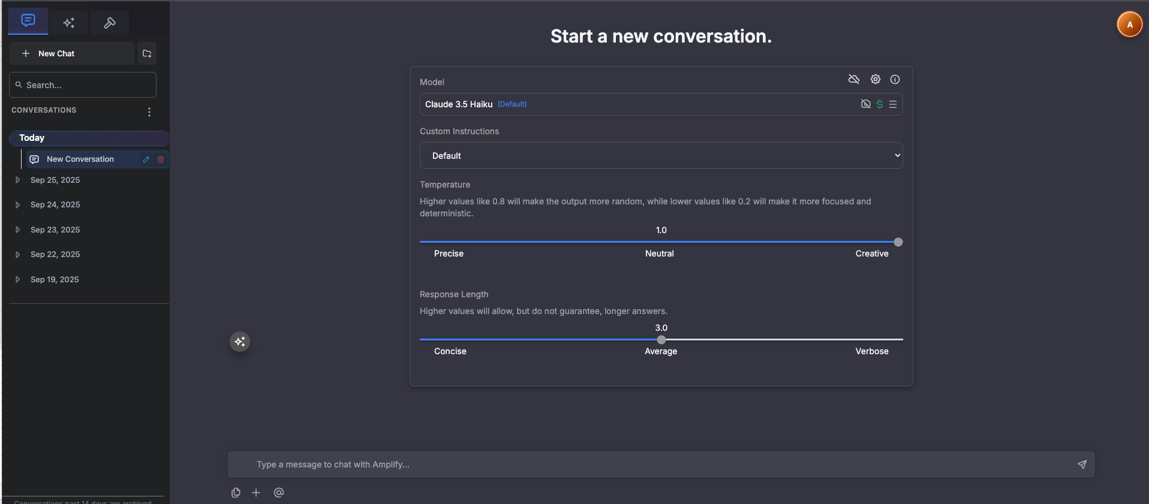

Conversation Storage
Amplify lets you decide where chats are stored. Go to Settings → Conversation Storage to choose Local Storage (private to the current browser) or Cloud Storage (available across devices). You can choose to move all existing conversations to the selected location or apply the setting only to new conversations. Local storage offers maximum privacy but is limited to the current device, whereas cloud storage allows seamless access from anywhere.
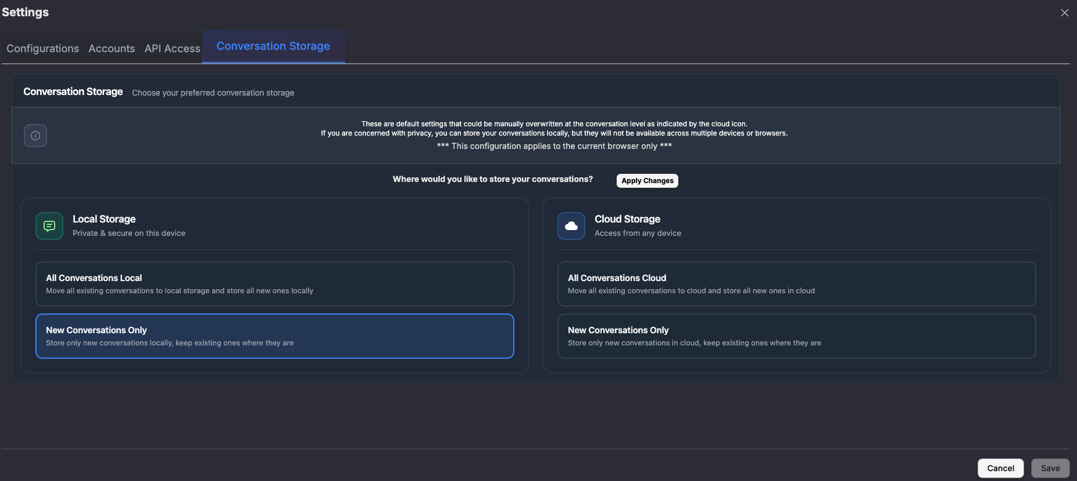

Importing & Exporting Conversations
From the Administration tab (hammer icon), you can Export Conversations to back up your chats or Import Conversations to restore them. Exported files can be shared with colleagues or moved between devices. Only import files that you trust, since they will appear in your chat history.

Building Assistants
Amplify’s most powerful feature is the ability to create custom assistants—similar to GPTs—that automatically answer questions based on your documents and data[4]. Assistants can be shared across your organization and tailored to specific roles (e.g., finance or HR).

Creating an Assistant
- Navigate to the Assistants tab and click Add Assistant.
- You may optionally auto‑populate fields from an existing assistant to speed configuration.
- Provide an Assistant Name, Description and Instructions. The instructions define your assistant’s purpose and tone; you can include variables using {{variable}} syntax (e.g., {{name}} is a {{adjective}} {{noun}}).
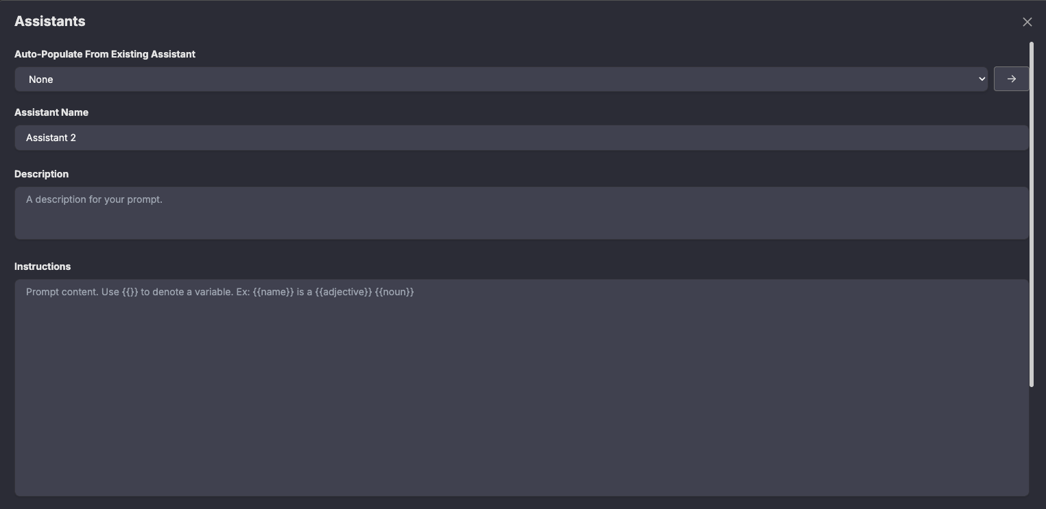

Attaching Data
Assistants derive their expertise from the data you provide. Under the assistant editor, you can:
- Upload files (PDFs, Word documents, spreadsheets) or drag them into the upload area.
- Attach website data sources by entering a URL or sitemap and toggling This is a sitemap if needed.
- Set a disclaimer to append to the assistant’s answers (e.g., “This information is for internal use only”).
You can also configure advanced options: allow other users to request chat permissions, include download links for referenced documents, insert message IDs/line numbers and decide whether the assistant can create artifacts (markdown files, diagrams or presentations).
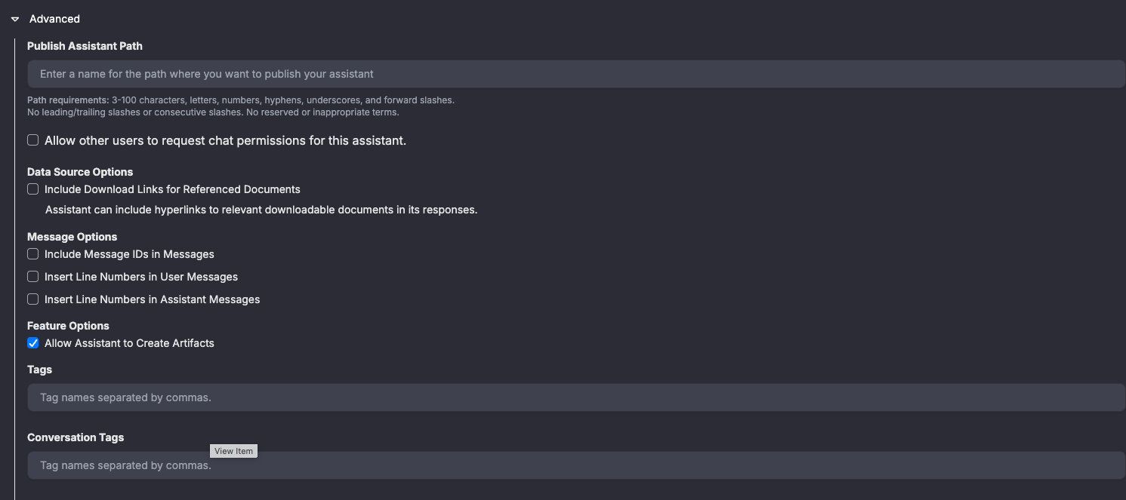

Prompt Templates & Amplify Helpers
Prompt templates let you save reusable prompts with variables. In the Assistants tab, click Prompt Template and enter a template title, description and body using variables in curly braces. Amplify includes built‑in Amplify Helpers, such as Summary with Quotations, CSV Extractor, Create PowerPoint and Create Visualization. These helpers generate formatted outputs or artifacts automatically—perfect for summarizing research papers or converting data into presentations.

Administration & Settings

User Settings
From Settings, users can configure accounts and API keys:
- Accounts – Add COA (chart of accounts) strings for billing. You can create multiple accounts, set rate limits and choose a default account for new conversations.
- API Access – Generate Personal, System or Delegate API keys. Personal keys allow you to interact directly with Amplify’s APIs; system keys are ideal for automated processes; delegate keys grant another user limited access. Always store keys securely; they are shown only at creation time.
- Conversation Storage – Choose local or cloud storage for chats, as discussed earlier.

Admin Interface
Users with the Admin role access deeper configuration options via Admin Interface. The interface has several tabs:

Configurations
- Admins – Add or remove administrators who can manage the platform.
- Support Email – Set a contact email to enable features like “Send Feedback.”
- Chat Rate Limit – Control the maximum number of messages per minute to manage usage spikes.
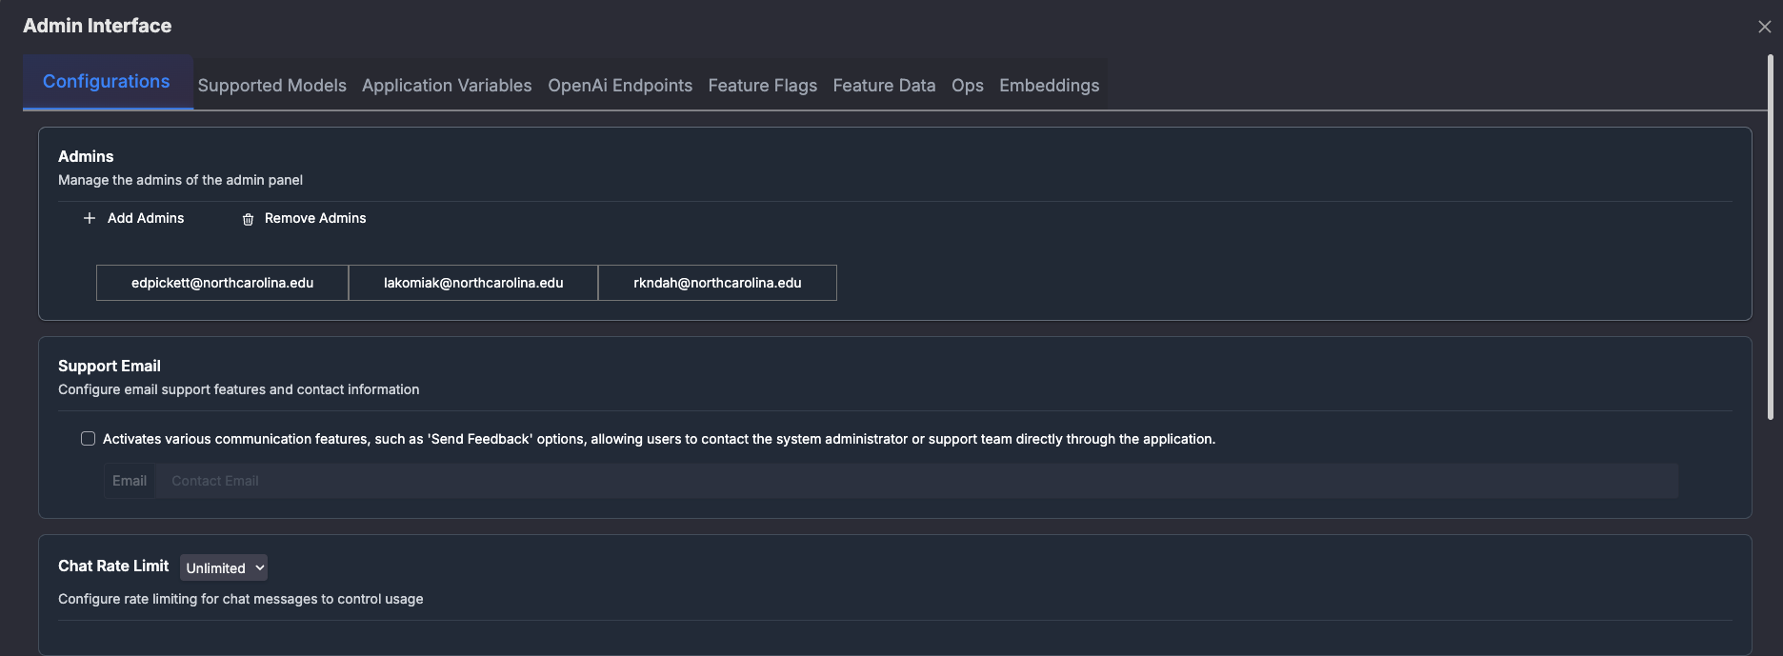

Supported Models
Amplify supports a growing list of AI models. In Supported Models, administrators can choose the default User Model, Simple Task Model, Advanced Task Model, Document Caching Model and Embeddings Model. A table lists each model’s provider (e.g., Bedrock or Azure), input context window, output token limit and token costs. You can enable or disable models, indicate whether they support images or reasoning and assign them to specific groups.
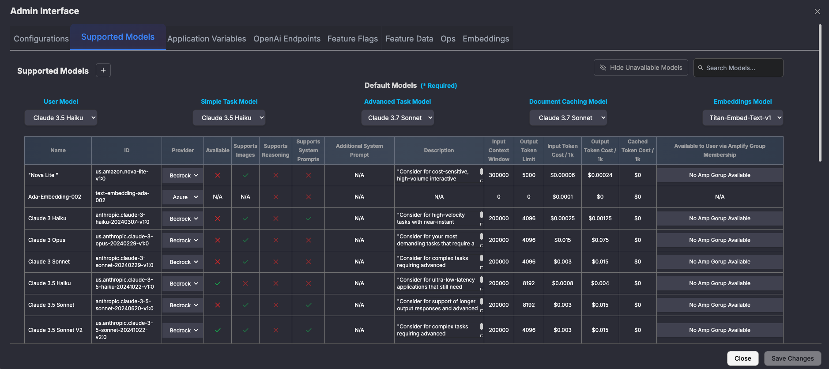

Application Variables
Use the Application Variables tab to manage sensitive secrets (e.g., Cognito client secret, NextAuth secret, OpenAI API key) and set environment variables such as the default function‑call model, Assistants API base URL, Azure deployment ID and available models. Only administrators should edit these values.

OpenAI Endpoints
For organizations running models via OpenAI, you can configure endpoint URLs and API keys under OpenAi Endpoints. Each model (e.g., gpt‑4‑turbo, gpt‑4o, gpt‑4o‑mini) has fields for its base URL and secret key. You can add new endpoints or rotate keys here.

Feature Flags
Feature flags let administrators enable or disable specific platform features for all users or grant exceptions to certain users/groups. Examples include enabling the Assistant Admin Interface, Cached Documents or Code Interpreter. When a feature is enabled, it is active for everyone except users listed under User Exceptions; when disabled, only those listed will retain access.
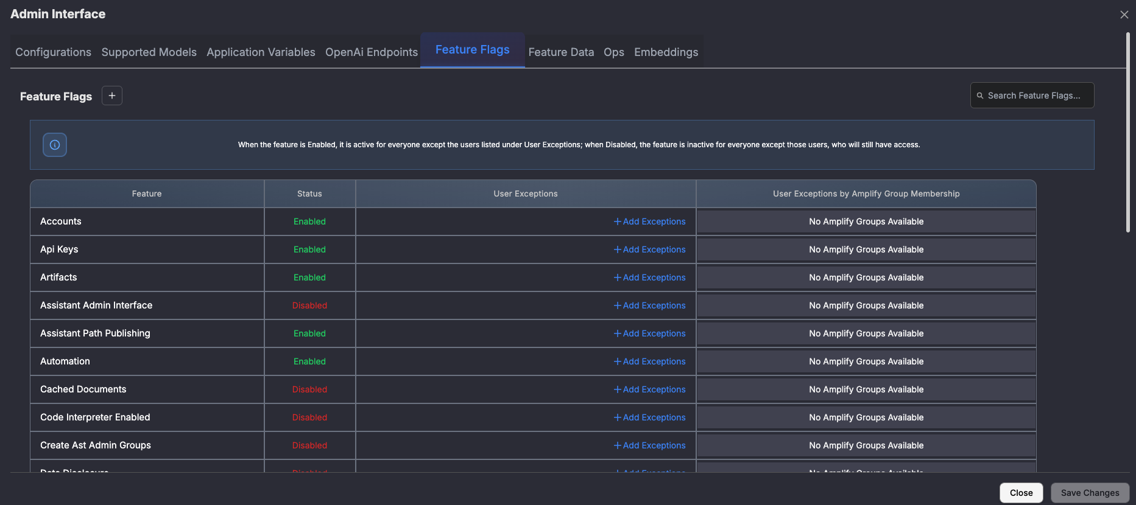

Feature Data & Built‑in Assistants
Under Feature Data, administrators can upload Data Disclosure PDFs and API documentation (PDF, CSV or Postman collection) to be referenced by assistants. You can also create Assistant Admin Groups to manage access control. Amplify ships with pre‑built assistants—Assistant Creator, API Document Helper and Amplify API Key Manager—which guide users through creating new assistants, exploring the Amplify API and managing API keys respectively.
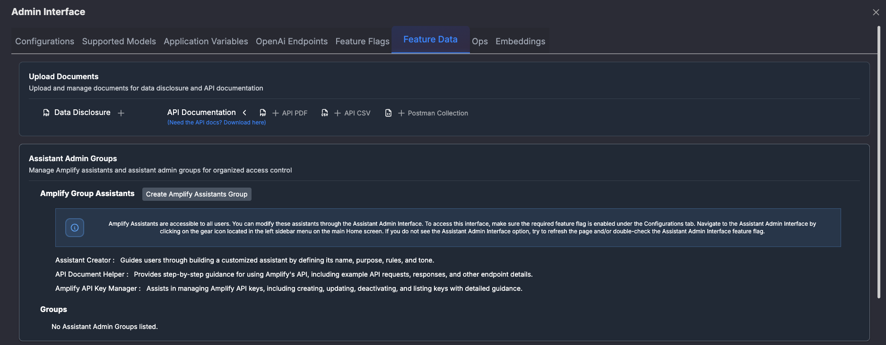

Ops (Custom Operations)
Ops allow administrators to register custom operations that assistants can execute against internal Amplify APIs. Each op requires a tag, function name, endpoint path, HTTP method, description and parameters. To use an op in an assistant, include the tag in the instructions using {{ops <op_tag>}}. The platform will automatically generate an auto block to call the op when needed.
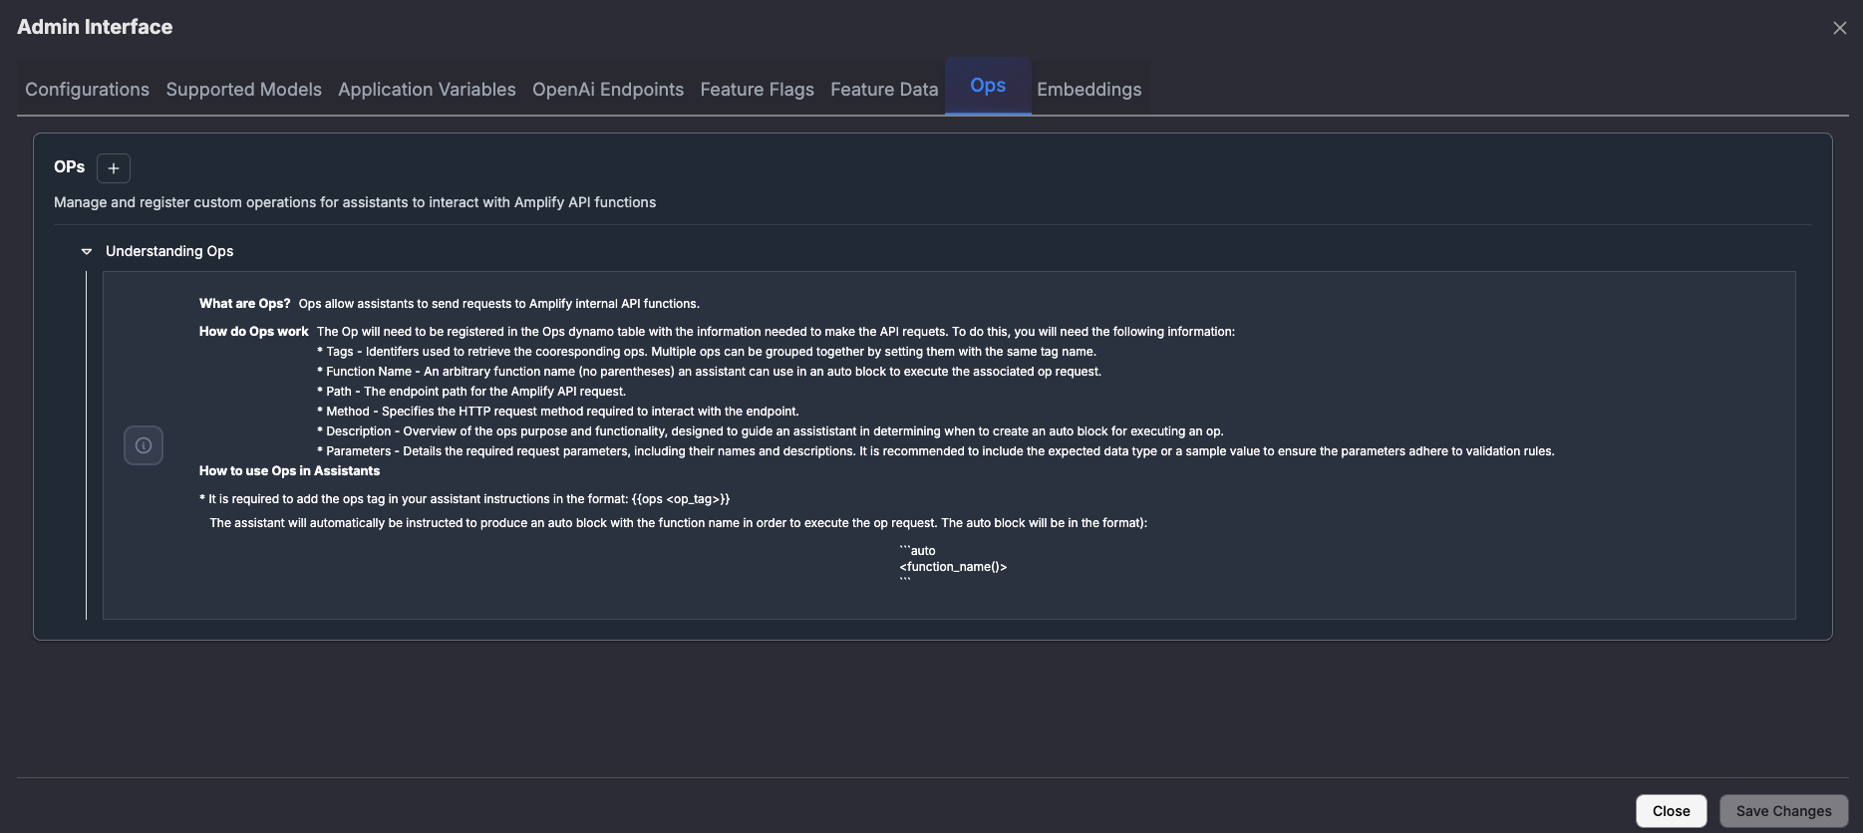

Cost Management
Amplify’s billing system tracks token usage per message and per user. Administrators can set Prompt Cost Alerts in the Admin Interface to notify users when the estimated cost of their prompt exceeds a specified threshold. The alert message supports dynamic placeholders such as <totalCost> and <prompts> to show the computed cost and number of prompts required. Amplify Groups can also be created to organize users and apply cost controls collectively.
Case studies from Vanderbilt show that by paying only for actual usage, half of users incurred less than US$1 per month in token costs, and the average per‑user cost (including AWS infrastructure) was about US$3 per month[3]. This highlights the cost‑effectiveness of a usage‑based model compared with traditional per‑seat licensing.

Prompting Language & Output Formats
Amplify extends the chatbot UI with a prompting language for generating structured outputs. The documentation provides examples for requesting CSV or JSON outputs and JSON‑schema‑validated responses:
- CSV Format – Use the csv({name:"string", age:"string"}) command followed by your question. Amplify returns a CSV with columns matching the keys and types you specify[5].
- JSON Object Format – Use json({name:"string", age:"string"}) to receive a simple JSON object in the specified structure[6].
- JSON Schema Validation – Use json!({ ...schema... }) to enforce a JSON schema (e.g., requiring name to be a string and age a non‑negative integer). This ensures the output adheres to the provided schema[7].
These formats are useful when extracting data from models or integrating Amplify with downstream systems.

Best Practices
- Organize your data: Tag uploaded files and organize them into folders for easier retrieval.
- Use assistants for domain‑specific tasks: Create specialized assistants (e.g., policy bots, finance assistants) that include relevant documents and instructions.
- Monitor cost: Regularly review token usage via the cost dashboard and set cost alerts to avoid surprises.
- Leverage built‑in helpers: Use Amplify’s helper templates for summarizing documents, generating slides, or creating diagrams instead of crafting prompts from scratch.
- Enable only necessary features: Use feature flags to disable unused functionality (e.g., Code Interpreter) for security and cost control.
- Rotate API keys: Regularly rotate API keys and remove unused keys from the API Access panel.

Conclusion
Amplify GenAI empowers organizations to build secure, customizable generative AI solutions. Its open architecture and usage‑based pricing provide flexibility while supporting advanced features such as custom assistants, prompt templates, file management, cost accounting and fine‑grained administration. By understanding the platform’s capabilities and following best practices, you can quickly integrate generative AI into your workflows and provide AI‑powered assistance across your organization.

[1] [2] [3] [4] Amplify GenAI
https://www.amplifygenai.org/
[5] [6] [7] raw.githubusercontent.com
https://raw.githubusercontent.com/gaiin-platform/amplify-genai-frontend/main/README.md

